**Chinmaya Vidyalaya senior secondary school, Ch – 92**

**ARADHANA DAY (FORENOON SESSION)**

**DATE: 03.08.24**

**VENUE: Chinmaya Kalaiarangam, CVV**

**Learning Objectives:** To inculcate a sense of reverence to our Gurudev and emphasise the importance to have a vision to follow his mission.

**Description:** Maha Aradhana day was celebrated in our school premises on 03.08.2024. Students of classes 9-12 attended te forenoon session and took part in the Padhuka Puja. Various Bhajans were sung in great reverence to our Gurudev. Swami. Sureshanandaji graced the occasion and addressed the gathering. He emphasised the children to stay focused and stay motivated. Various activities based on Aradhana day like chanting the Guru Stothram, quiz on the book “Why do we” and the movie “On a Quest” etc were conducted class wise during the previous week and the prize winners were awarded by Swamiji.

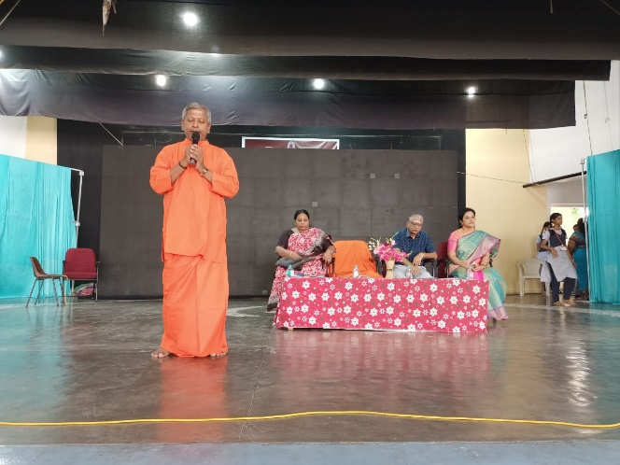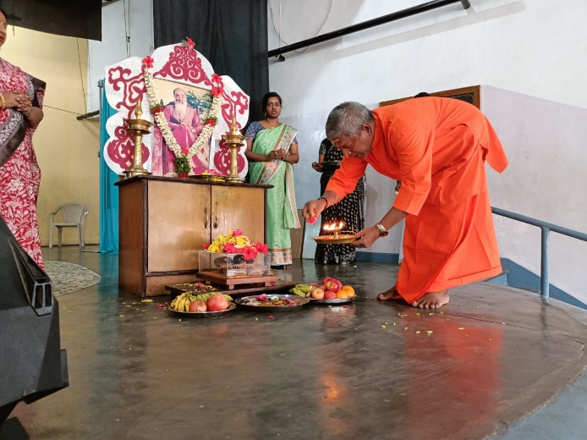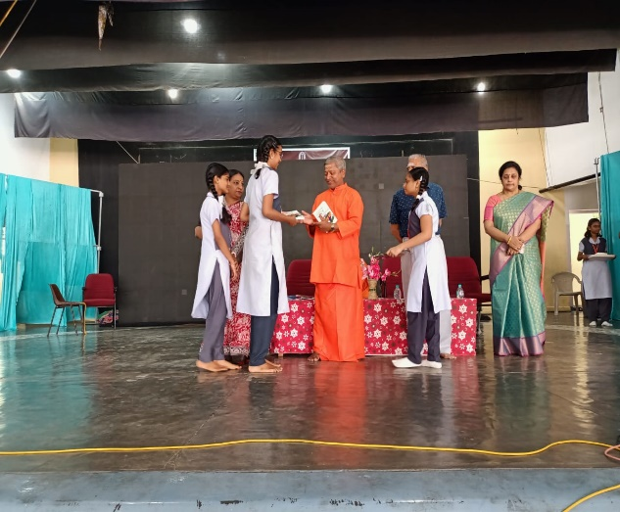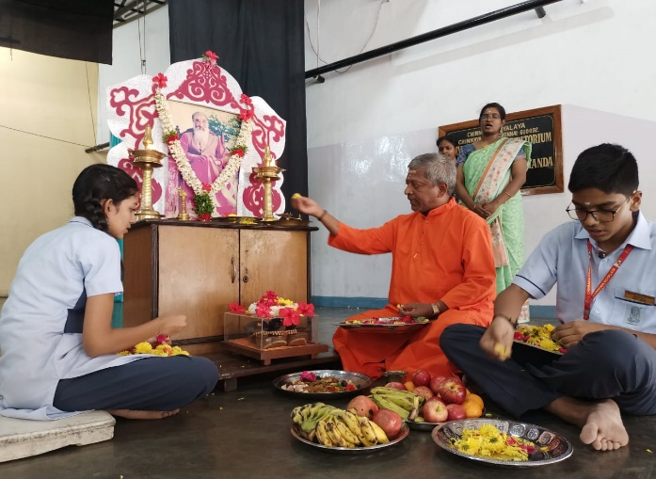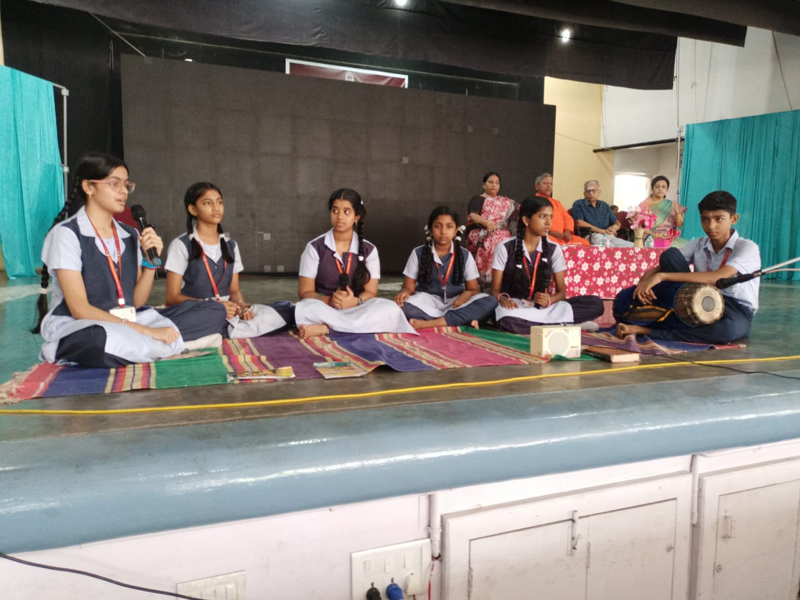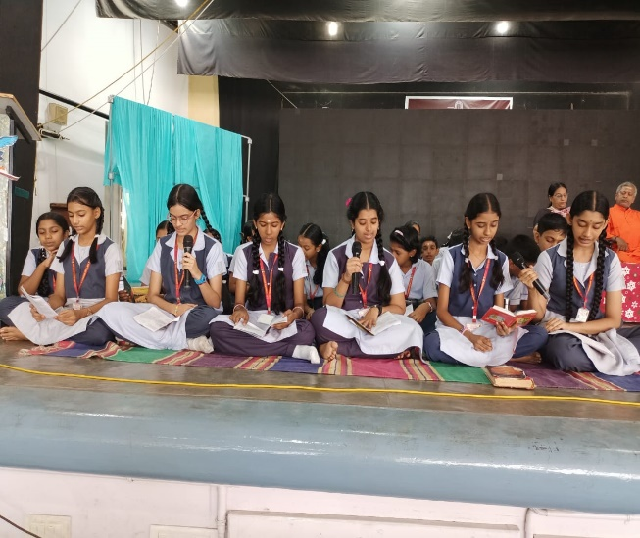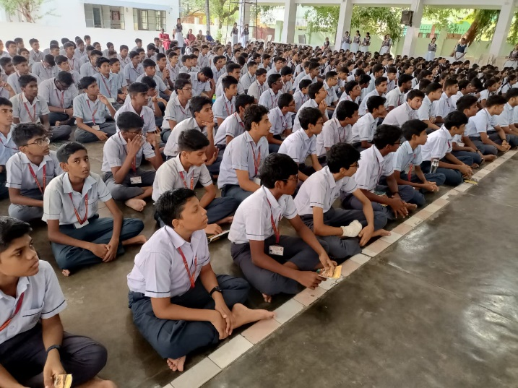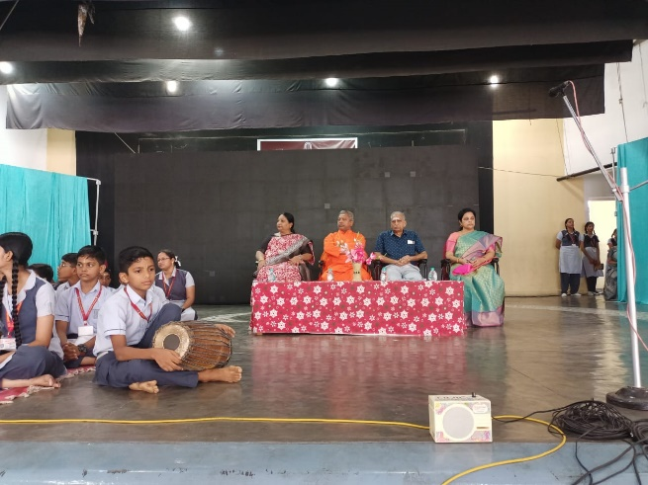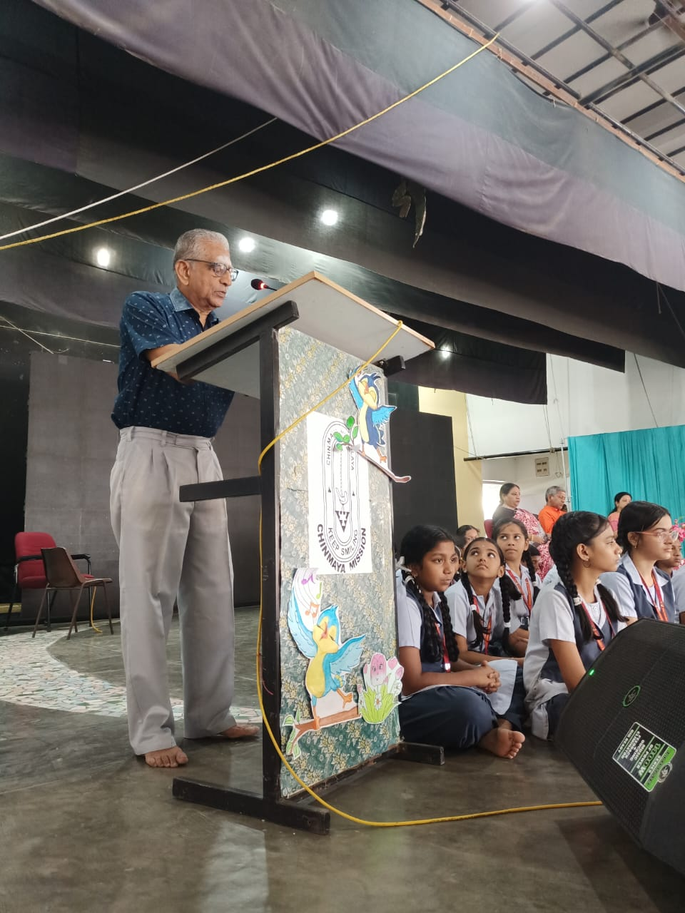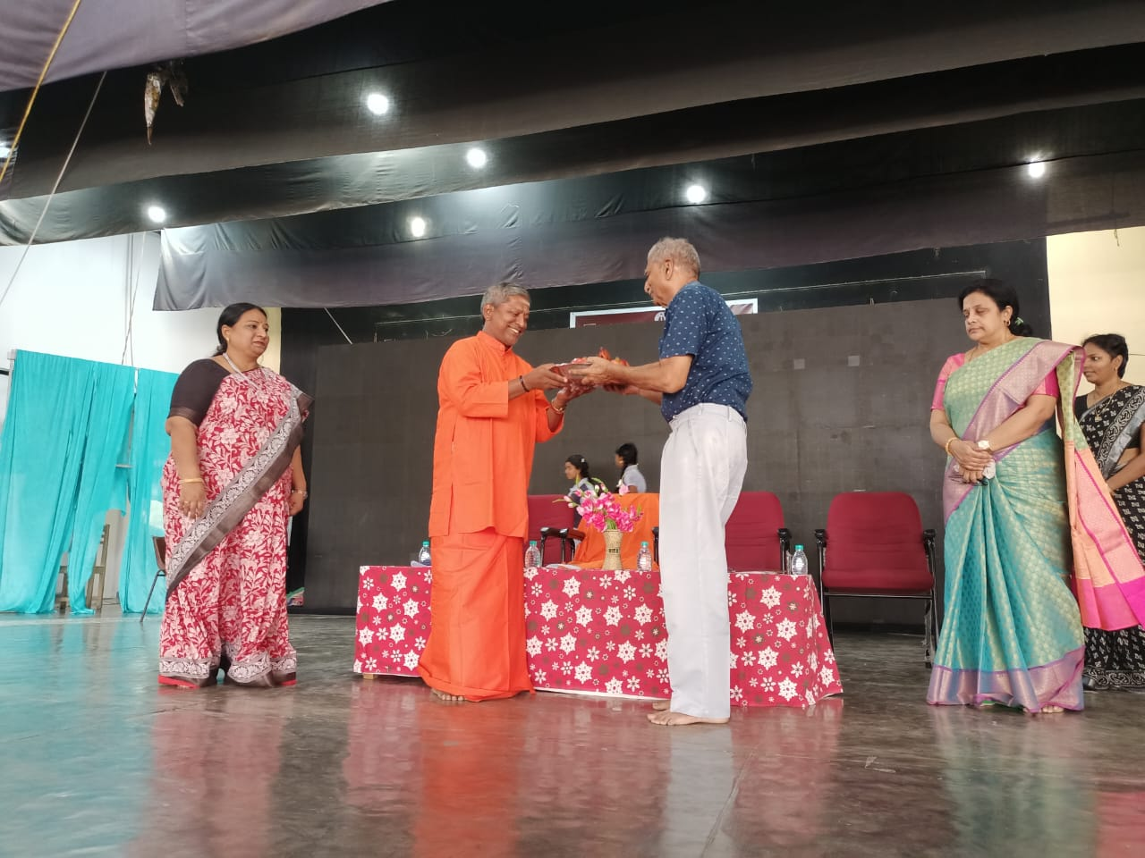

**Learning outcome**: Students understood the importance of celebrating Aradhana day. Celebrating this day made them determined to follow the footsteps of our Gurudev and make his vision as their mission.

CVP: Integrated development: Intellectual ability: Various activities like the chanting of Guru Sthothtram and quiz kindled the young minds and improved their intellectual ability.

Emotional development: Children understood the vision of our Gurudev and became determined to do their best to become better individuals with holistic development.

*************************